There are **5** basic operators in bash/shell scripting:

* Arithmetic Operators
* Relational Operators
* Boolean Operators
* Bitwise Operators
* File Test Operators

**1. Arithmetic Operators**: These operators are used to perform normal arithmetics/mathematical operations. There are 7 arithmetic operators:

* **Addition (+)**: [Binary operation](https://www.geeksforgeeks.org/binary-operation/) used to add two operands.
* **Subtraction (-)**: Binary operation used to subtract two operands.
* **Multiplication (*)**: Binary operation used to multiply two operands.
* **Division (/)**: Binary operation used to divide two operands.
* **Modulus (%)**: Binary operation used to find remainder of two operands.
* **Increment Operator (++)**: Unary operator used to increase the value of operand by one.
* **Decrement Operator (- -)**: Unary operator used to decrease the value of a operand by one

#!/bin/bash

# reading data from the user

read -r -p "Enter a: " a

read -r -p "Enter b: " b

add=$((a+b))

echo "Addition of a and b are: "${add}

sub=$((a-b))

echo "Subtraction of a and b are: "${sub}

mul=$((a*b))

echo "Multiplication of a and b are: "${mul}

div=$((a/b))

echo "Division of a and b are: "${div}

mod=$((a%b))

echo "Modulis of a and b are: "${mod}

((++a))

echo "Increment operator when applied on $a results into a :" "${a}"

((--b))

echo "Decrement operator when applied on 'b' results into b :" "${b}"

**Output:**

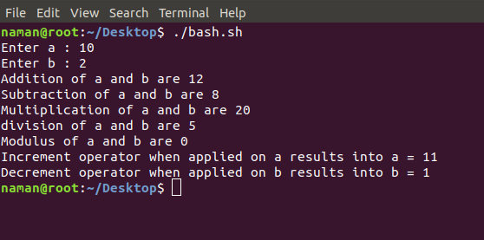

**2. Relational Operators**: Relational operators are those operators which define the relation between two operands. They give either true or false depending upon the relation. They are of 6 types:

* **‘==’ Operator**: Double equal to operator compares the two operands. Its returns true is they are equal otherwise returns false.
* **‘!=’ Operator**: Not Equal to operator return true if the two operands are not equal otherwise it returns false.
* **‘<‘ Operator**: Less than operator returns true if first operand is less than second operand otherwise returns false.
* **‘<=’ Operator**: Less than or equal to operator returns true if first operand is less than or equal to second operand otherwise returns false
* **‘>’ Operator**: Greater than operator return true if the first operand is greater than the second operand otherwise return false.
* **‘>=’ Operator**: Greater than or equal to operator returns true if first operand is greater than or equal to second operand otherwise returns false

#!/bin/bash

#reading data from the user

read -p 'Enter a : ' a

read -p 'Enter b : ' b

**if**(( $a==$b ))

then

echo a is equal to b.

**else**

echo a is not equal to b.

fi

**if**(( $a!=$b ))

then

echo a is not equal to b.

**else**

echo a is equal to b.

fi

**if**(( $a<$b ))

then

echo a is less than b.

**else**

echo a is not less than b.

fi

**if**(( $a<=$b ))

then

echo a is less than or equal to b.

**else**

echo a is not less than or equal to b.

fi

**if**(( $a>$b ))

then

echo a is greater than b.

**else**

echo a is not greater than b.

fi

**if**(( $a>=$b ))

then

echo a is greater than or equal to b.

**else**

echo a is not greater than or equal to b.

fi

**Output:**

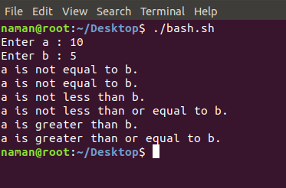

**3. Logical Operators** : They are also known as boolean operators. These are used to perform logical operations. They are of 3 types:

* **Logical AND (&&)**: This is a binary operator, which returns true if both the operands are true otherwise returns false.
* **Logical OR (||)**: This is a binary operator, which returns true if either of the operands is true or if both the operands are true. It returns false only if both operands are false.
* **Not Equal to (!)**: This is a unary operator which returns true if the operand is false and returns false if the operand is true.

#!/bin/bash

#reading data from the user

read -p 'Enter a : ' a

read -p 'Enter b : ' b

**if**(($a == "true" & $b == "true" ))

then

echo Both are true.

**else**

echo Both are not true.

fi

**if**(($a == "true" || $b == "true" ))

then

echo Atleast one of them is true.

**else**

echo None of them is true.

fi

**if**(( ! $a == "true" ))

then

echo "a" was initially false.

**else**

echo "a" was initially true.

fi

**Output:**

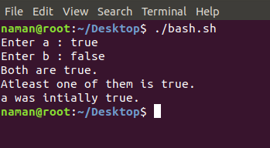

**4. Bitwise Operators**: A bitwise operator is an operator used to perform bitwise operations on bit patterns. They are of 6 types:

* **Bitwise And (&)**: Bitwise & operator performs binary AND operation bit by bit on the operands.
* **Bitwise OR (|)**: Bitwise | operator performs binary OR operation bit by bit on the operands.
* **Bitwise XOR (^)**: Bitwise ^ operator performs binary XOR operation bit by bit on the operands.
* **Bitwise complement (~)**: Bitwise ~ operator performs binary NOT operation bit by bit on the operand.
* **Left Shift (<<)**: This operator shifts the bits of the left operand to left by number of times specified by right operand.
* **Right Shift (>>)**: This operator shifts the bits of the left operand to right by number of times specified by right operand.

#!/bin/bash

#reading data from the user

read -p 'Enter a : ' a

read -p 'Enter b : ' b

bitwiseAND=$(( a&b ))

echo Bitwise AND of a and b is $bitwiseAND

bitwiseOR=$(( a|b ))

echo Bitwise OR of a and b is $bitwiseOR

bitwiseXOR=$(( a^b ))

echo Bitwise XOR of a and b is $bitwiseXOR

bitiwiseComplement=$(( ~a ))

echo Bitwise Compliment of a is $bitiwiseComplement

leftshift=$(( a<<1 ))

echo Left Shift of a is $leftshift

rightshift=$(( b>>1 ))

echo Right Shift of b is $rightshift

**Output:**

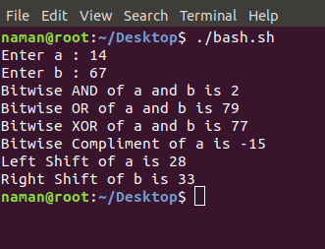

**5. File Test Operator**: These operators are used to test a particular property of a file.

* **-b operator**: This operator check whether a file is a block special file or not. It returns true if the file is a block special file otherwise false.
* **-c operator**: This operator checks whether a file is a character special file or not. It returns true if it is a character special file otherwise false.
* **-d operator**: This operator checks if the given directory exists or not. If it exists then operators returns true otherwise false.
* **-e operator**: This operator checks whether the given file exists or not. If it exits this operator returns true otherwise false.
* **-r operator**: This operator checks whether the given file has read access or not. If it has read access then it returns true otherwise false.
* **-w operator**: This operator check whether the given file has write access or not. If it has write then it returns true otherwise false.
* **-x operator**: This operator check whether the given file has execute access or not. If it has execute access then it returns true otherwise false.
* **-s operator**: This operator checks the size of the given file. If the size of given file is greater than 0 then it returns true otherwise it is false.

#!/bin/bash

#reading data from the user

read -p 'Enter file name : ' FileName

**if** [ -e $FileName ]

then

echo File Exist

**else**

echo File doesnot exist

fi

**if** [ -s $FileName ]

then

echo The given file is not empty.

**else**

echo The given file is empty.

fi

**if** [ -r $FileName ]

then

echo The given file has read access.

**else**

echo The given file does not has read access.

fi

**if** [ -w $FileName ]

then

echo The given file has write access.

**else**

echo The given file does not has write access.

fi

**if** [ -x $FileName ]

then

echo The given file has execute access.

**else**

echo The given file does not has execute access.

fi

**Output:**

